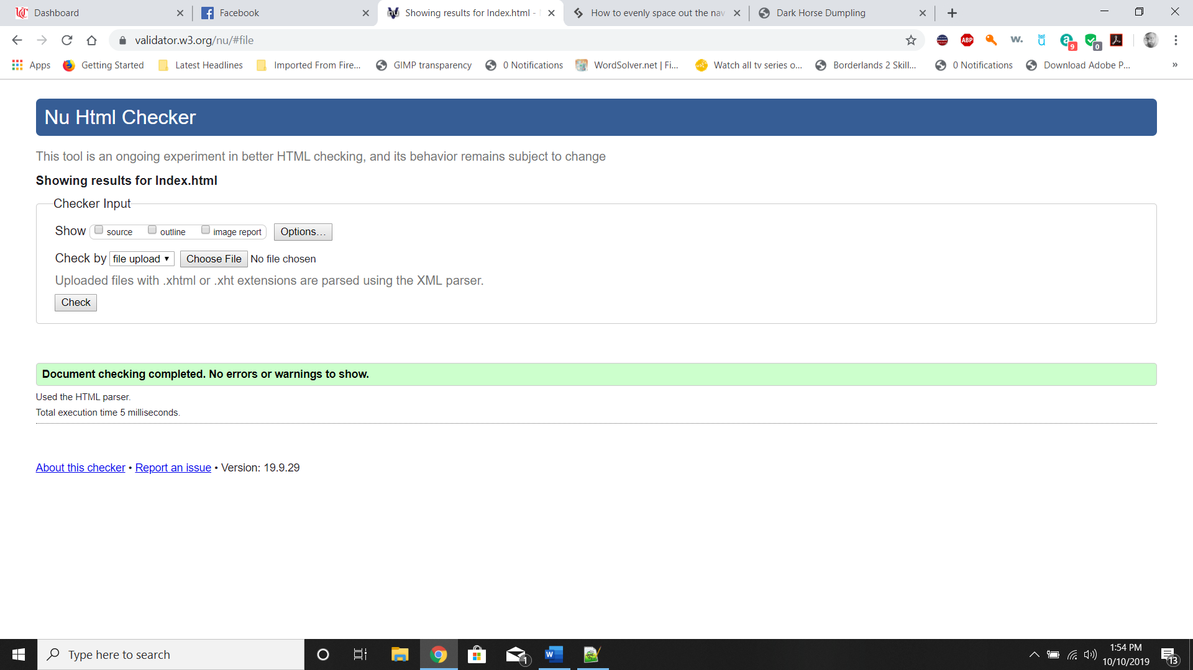

Figure 1 Index.html HTML Validation

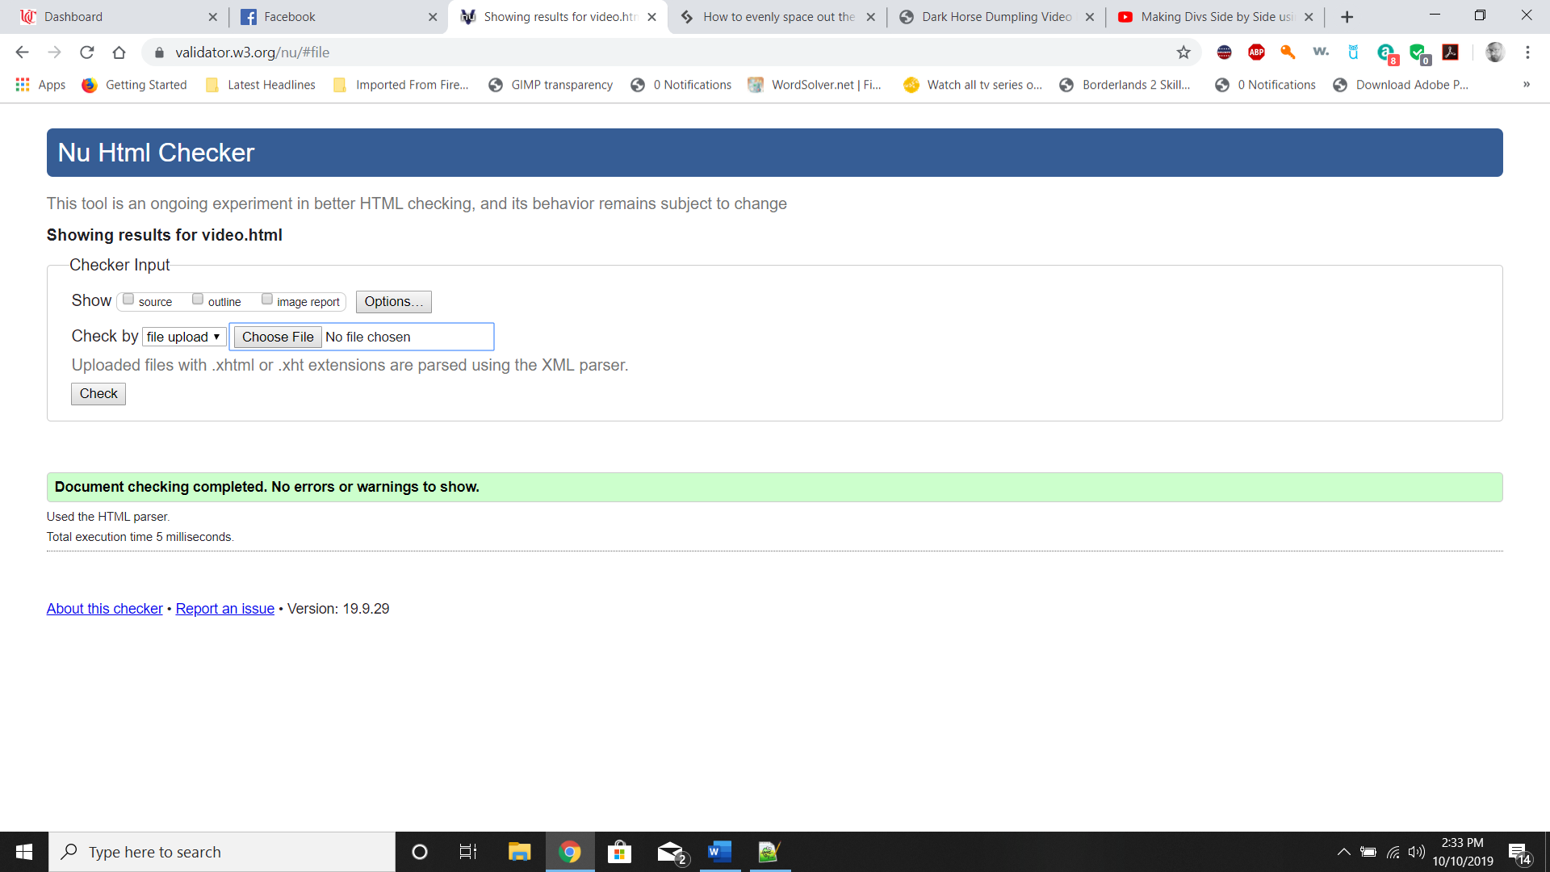

Figure 2 Video.html HTML Validation

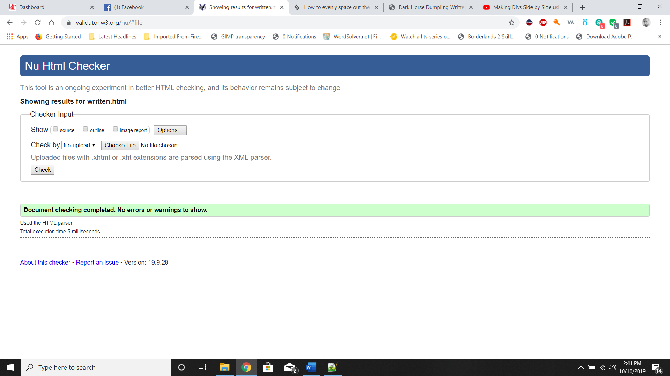

Figure 3 Written.html HTML Validation

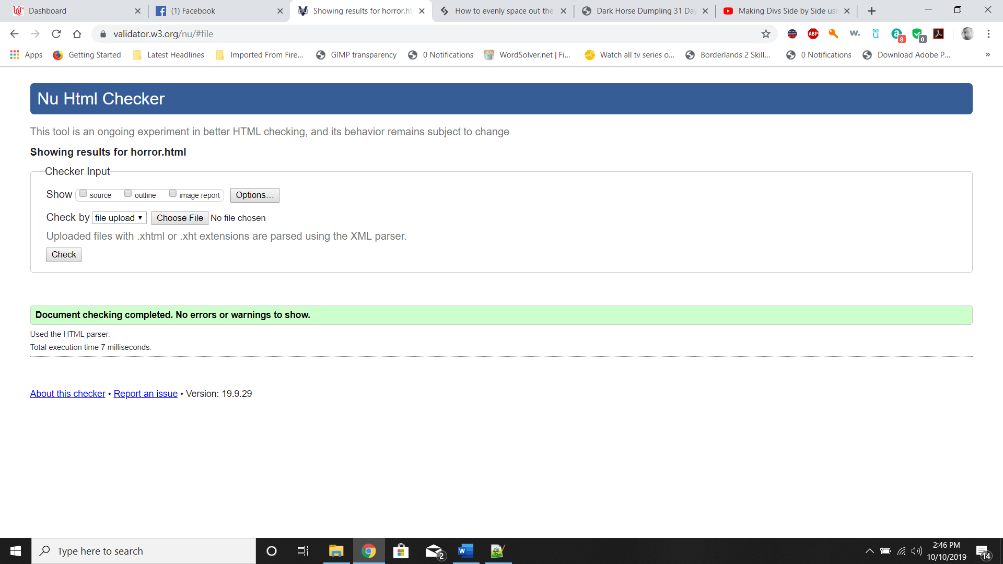

Figure 4 Horror.html HTML Validation

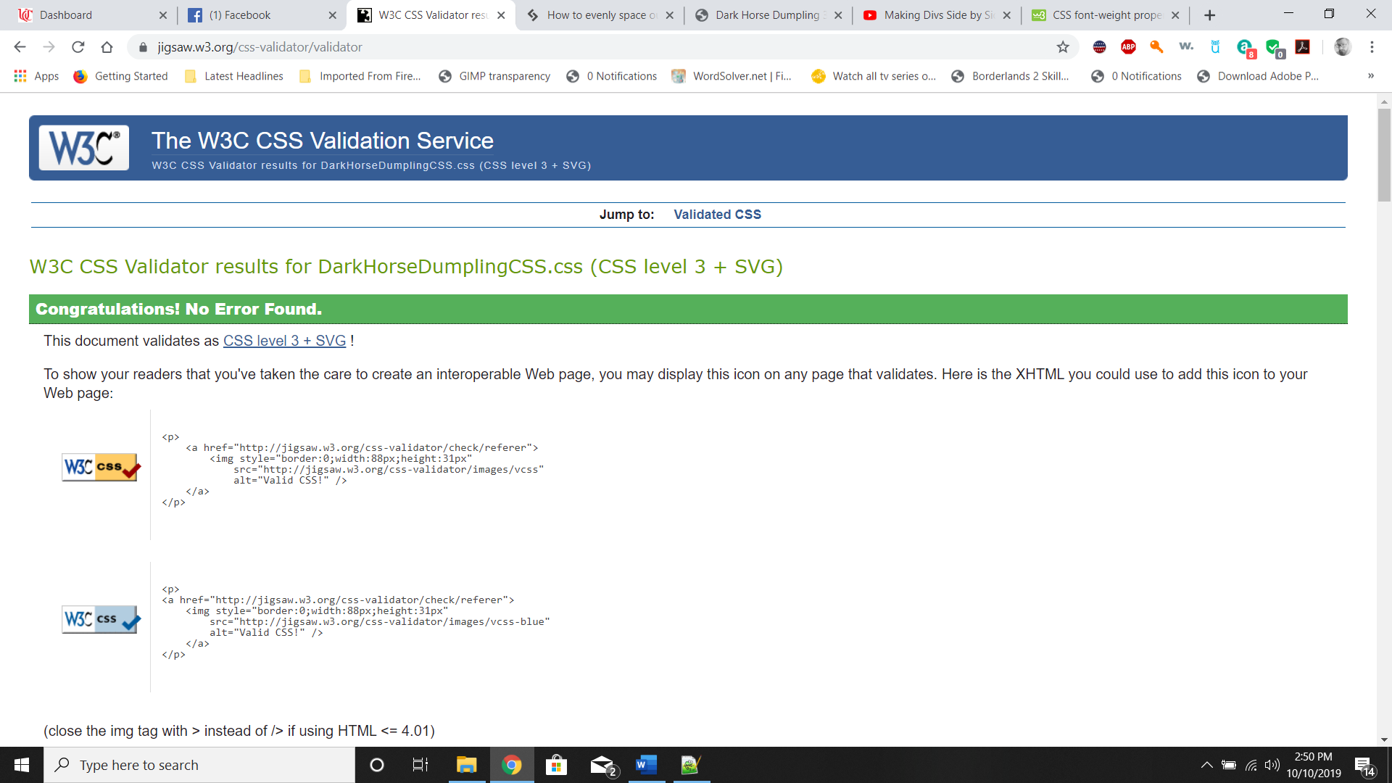

Figure DarkHorseDumpling.css CSS Validation